SULAMAN BASHIR 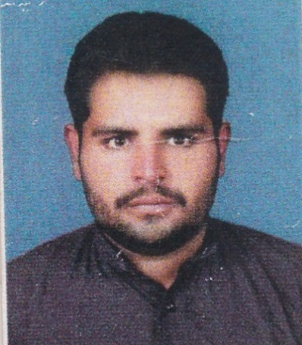

Balochan post office mankot tehsil Kabirwala Distt.Khanewal.

E. Mail Address***:-*** [***sulamanbashir551@gmail.com***](mailto:sulamanbashir551@gmail.com)

Cell No: +92-3049481558

|  |  |  |  |  |  |  |  |
| --- | --- | --- | --- | --- | --- | --- | --- |
| **Personal Detail:**  **Father Name: BASHIR AHMAD**  **Date Of Birth: 12-NOV-1993**  **CNIC Number: 36102-7538580-7**  **Nationality: Pakistani**  **Marital Status: Single**  **Gender: Male** | | | | | | | |
| **CAREER OBJECTIVES:** | | | | | | | |
| To serve in a challenging job in an organization with leading edge technologies, where I can utilize my knowledge and can have a continual advancement of skill. | | | | | | | |
| **QUALIFICATION:** | | | | | | | |
| **Degree** | **Year** | **Marks Detail/GPA** | **Division** | **Subjects** | **Board/Inst** | |
| Matriculation | 2008 | 676/850 | 1st | Science | BISE Multan | |
| Intermediate | 2011 | 800/1100 | 1st | Science | BISE Multan | |
| Graduation | 2013 | 541/800 | 1st | Computer Science | B.Z.U Multan | |
| Masters | 2015 | 3.2/4.0 | 1st | Computer Science | B.Z.U Multan | |
| **COMPUTER SKILLS:**   * Microsoft Office * Web Development(Html5,php,css,java script) * C,C++,C#(using oop), Inpage, Photoshop, Database(Sql,mysqli)   EXTRA CURRICULAR ACTIVITIES | | | | | | |
| **LANGUAGE SKILLS:**   * English, Urdu. | | | | | | |
| **HOBBIES:**   * Study, Sight Seeing, internet suffering. | | | | | | |
| **Reference:**  Will Be Furnished Upon Demand. | | | | | | |